**PROJECT:- Reset password for windows**

* **Steps to Reset password for windows :-**

Step 1: Prepare a Windows 10 setup disk  
If you don’t have a reset disk, you can create one with media creation tool on another workable computer.

Step 2: Boot up password locked computer  
Inset the reset disk to the locked computer and then power on your PC. When vendor logo appears, choose Boot Option Key repeatedly until the Boot Option Menu shows up. Find the suitable Boot Option Key for your computer and choose the USB drive to boot your computer.

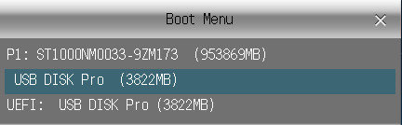

Step 3: Replace Utility Manager with Command Prompt

* After the computer boots up from installation disk, press “Shift + F10” to bring up command prompt.

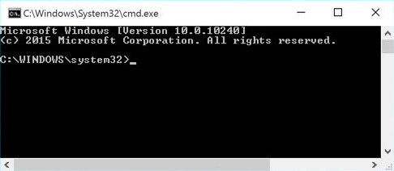

* Now you can execute command below to replace utility manager with command prompt  
  ***move d:\windows\system32\utilman.exe d:\  
  copy d:\windows\system32\cmd.exe d:\windows\system32\utilman.exe***

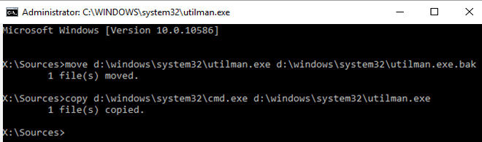

* Take out the setup disk and restart computer after the commands are executed

Step 4: Reset Windows 10 local admin password with command prompt

* When the login screen appears, click on the Ease of Access icon on the lower-right corner, the command prompt will show up
* Type the following password reset command in the windows and hit Enter to set a new password  
  ***net user***

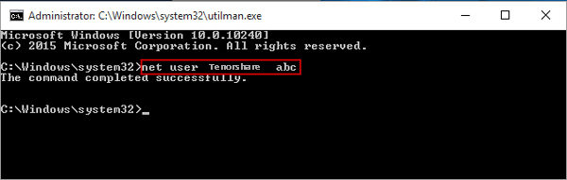

Step 5: Restore Utility Manager

* Insert the reset disk into computer and click the Power icon to restart
* When computer boots up from the disk, press Shift + F10 to open command prompt
* Type command ***"copy d:\utilman.exe d:\windows\system32\utilman.exe"***, press Enter, and then type "Yes" to restore Utility Manager.

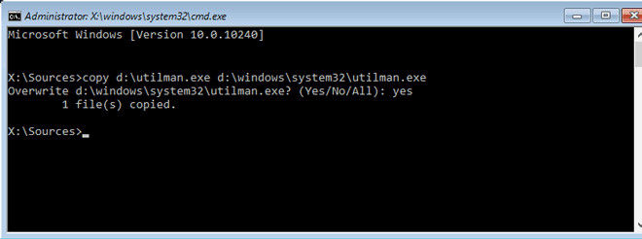

Step 6: Login Windows 10 with local admin account  
Close the command prompt window and reboot Windows 10 computer. Login with the admin account you have reset password successfully.